

Bachelor of Computer Applications
Semester – V
Business Analytics
Experiment No.: 1
Title: Building a Dashboard

Submitted By
Name: Suraj Mal Gurjar
Reg. No.:2411021240009
Date:04-09-2026

Submitted To:
Faculty Name: Mr. Aman Kumar Sharma

Department of Computer Application
Alliance University
Chandapura - Anekal Main Road, Anekal
Bengaluru – 562106

Experiment No.: 3
Building a Dashboard

Problem Statement
A pizza restaurant maintains its business data in multiple CSV files, including orders, order details, pizza information, and pizza categories. The objective is to import these datasets into Power BI, establish relationships between the tables, clean and transform the data, and develop an interactive dashboard that provides meaningful business insights for decision-making.

Methodology / Steps Followed

Step 1: Data Collection
- The pizza sales datasets were collected in CSV format. Four different files containing orders, order details, pizzas, and pizza categories were used as the data source for analysis.

Step 2: Data Import
- Opened Power BI Desktop.
- Imported all datasets using the Get Data option.
- Loaded Excel and CSV files into Power BI.

Step 3: Data Cleaning and Transformation
- Verifying data types (Date, Time, Text, Decimal).
- Removing unnecessary errors and duplicate records.
- Renaming columns where required.
- Creating Month and Year columns from the Order Date.
- Ensuring the Price column was stored as Decimal Number

Step 4: Data Modeling
Relationships were created between the four tables using one-to-many cardinality

- Imported and connected 4 CSV tables: Orders, Order Details, Pizzas, and Pizza Types.
- Created a one-to-many relationship between Orders and Order Details using Order ID.
- Created a one-to-many relationship between Pizzas and Order Details using Pizza ID.
- Created a one-to-many relationship between Pizza Types and Pizzas using Pizza Type ID.
- Verified that all relationships were active with single-direction filtering.
- Established a relational data model to enable accurate revenue and sales analysis.
These relationships enabled accurate calculation of revenue and product-wise analysis.
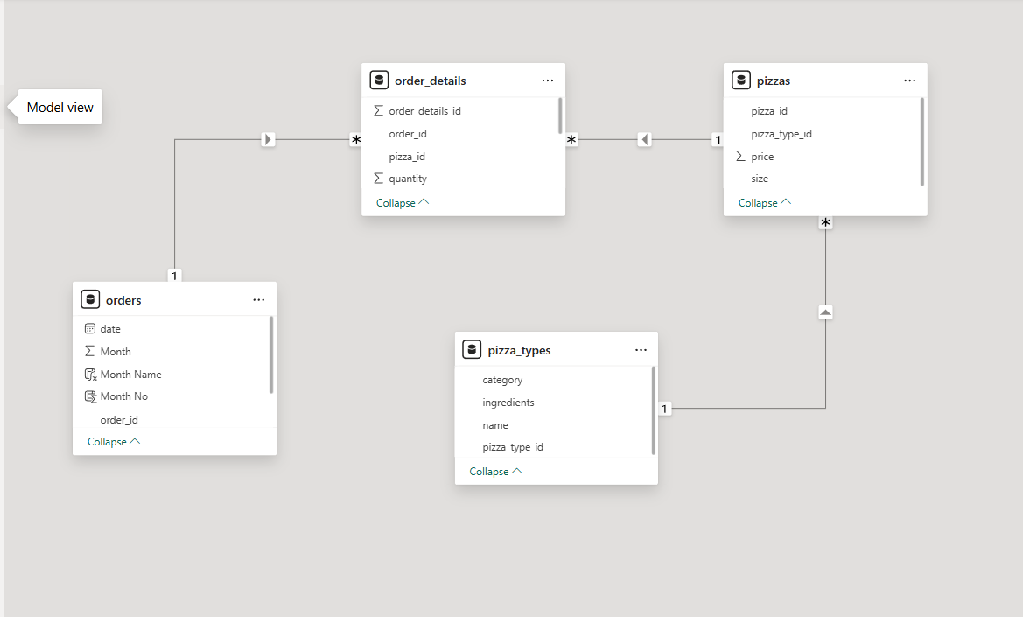

Step 5: Dashboard Development
An interactive dashboard was created using Power BI with the following visuals:
- Designed an interactive Pizza Sales Dashboard in Power BI.
- Created KPI cards for Total Revenue, Average Pizza Price, Average Order Value, and Total Pizzas Sold.
- Developed visualizations including bar, line, donut, and horizontal bar charts.
- Added interactive slicers for Month, Category, and Pizza Size.
- Applied a professional theme with consistent colors, formatting, and layout.
- Enabled cross-filtering between visuals for dynamic data exploration.
- Validated DAX measures to ensure accurate business reporting.
- Published the final dashboard for business performance analysis and decision-making
DAX
1.Total Revenue =SUMX( order_details, order_details[quantity] * RELATED(Pizzas[price]))
2. Total Orders =DISTINCTCOUNT(orders[order_id])
3. Total Pizzas Sold =SUM(order_details[quantity])
4. Avg Pizza Price =AVERAGE(Pizzas[price])
5. Avg Order Value =DIVIDE([Total Revenue],[Total Orders],0
Output
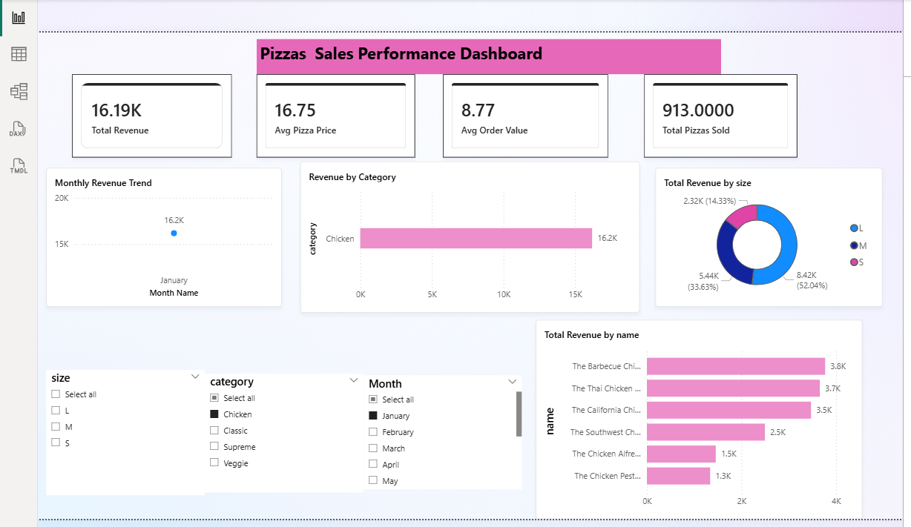
The developed Pizza Sales Dashboard provides:
- Total Revenue Performance
- Monthly Revenue Trend
- Pizza Category Analysis
- Pizza Size Revenue Distribution
- Top 10 Best-Selling Pizzas
- Interactive filtering using Month, Category, and Size slicers
Business Insights
- Total Revenue: 817.86K
- Average Pizza Price: 16.44
- Average Order Value: 38.31
- Total Pizzas Sold: 49.57K
The Classic category generated the highest revenue, while Large (L) pizzas contributed the largest share of overall sales. Monthly revenue showed noticeable fluctuations, with stronger sales during mid-year months.

Conclusion
This experiment successfully integrated multiple CSV datasets into Power BI and transformed raw pizza sales data into an interactive business dashboard. Data cleaning, transformation, relationship modeling, and DAX calculations were applied to generate accurate business reports. The dashboard provides a centralized view of sales performance and supports effective business decision-making.

Learning Outcomes
Through this project, I learned:
- How to import data from Excel and CSV files into Power BI.
- Data cleaning and transformation using Power Query.
- Creating relationships between multiple tables.
- Developing DAX measures and calculated columns.
- Designing interactive dashboards and reports.
- Generating business insights from raw data.

GitHub link : https://github.com/Suraj18-108/Business-Analytics-Projects

